**Station Approving Sellers**

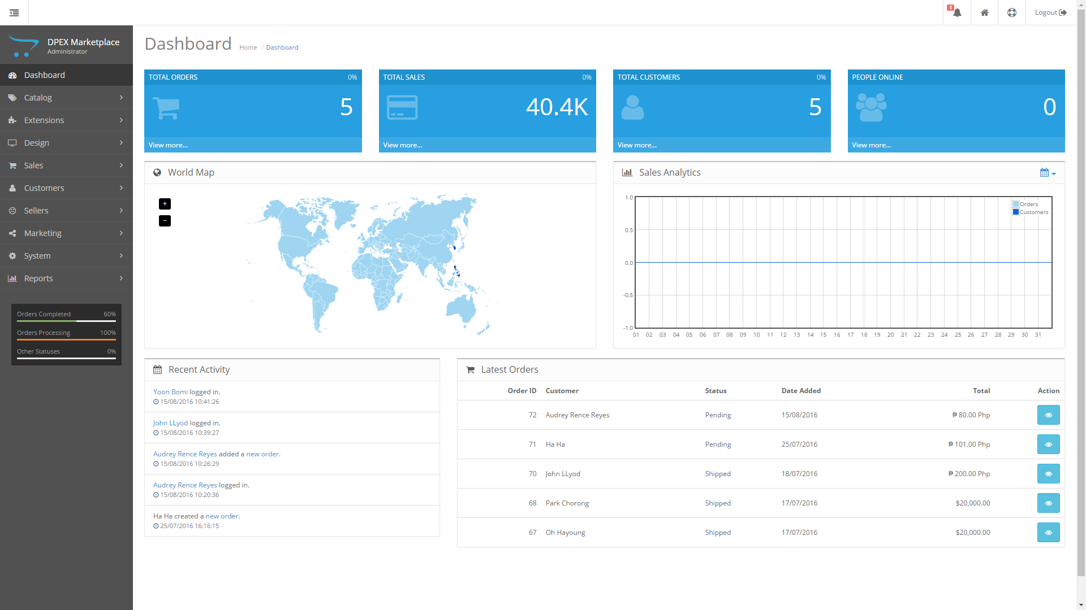

Click the customer tab located in the dashboard

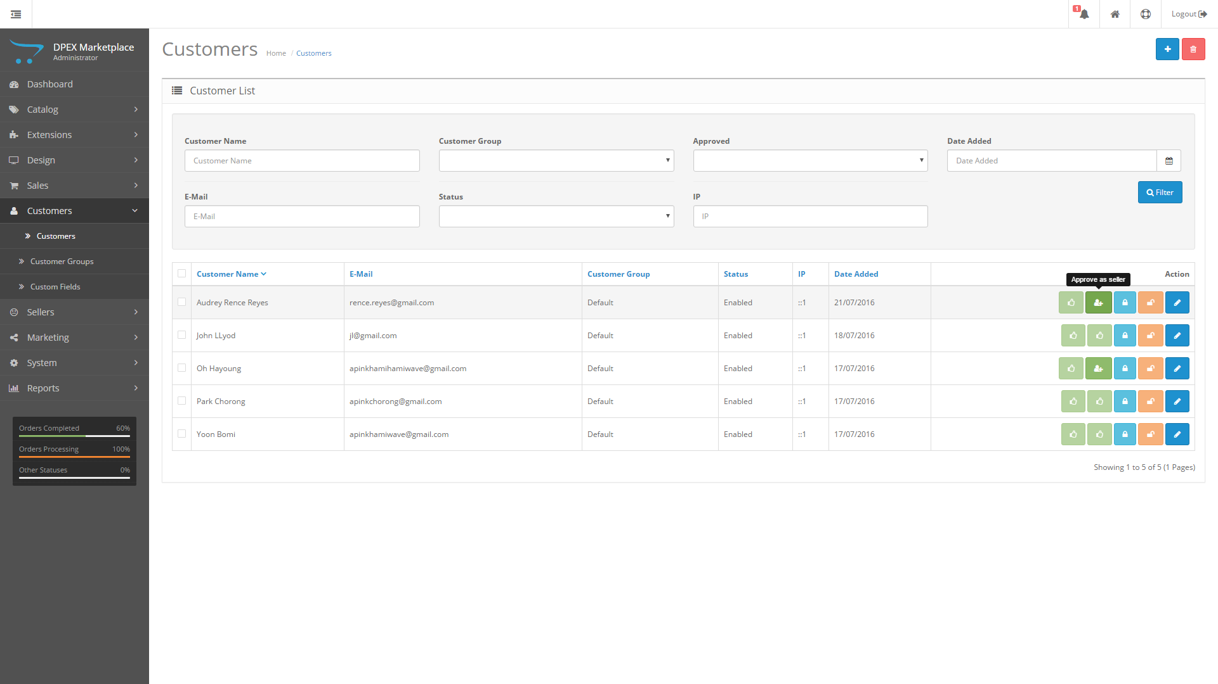

Simply click the approve as seller button in order to make the customer account a seller

**Viewing Merchants**

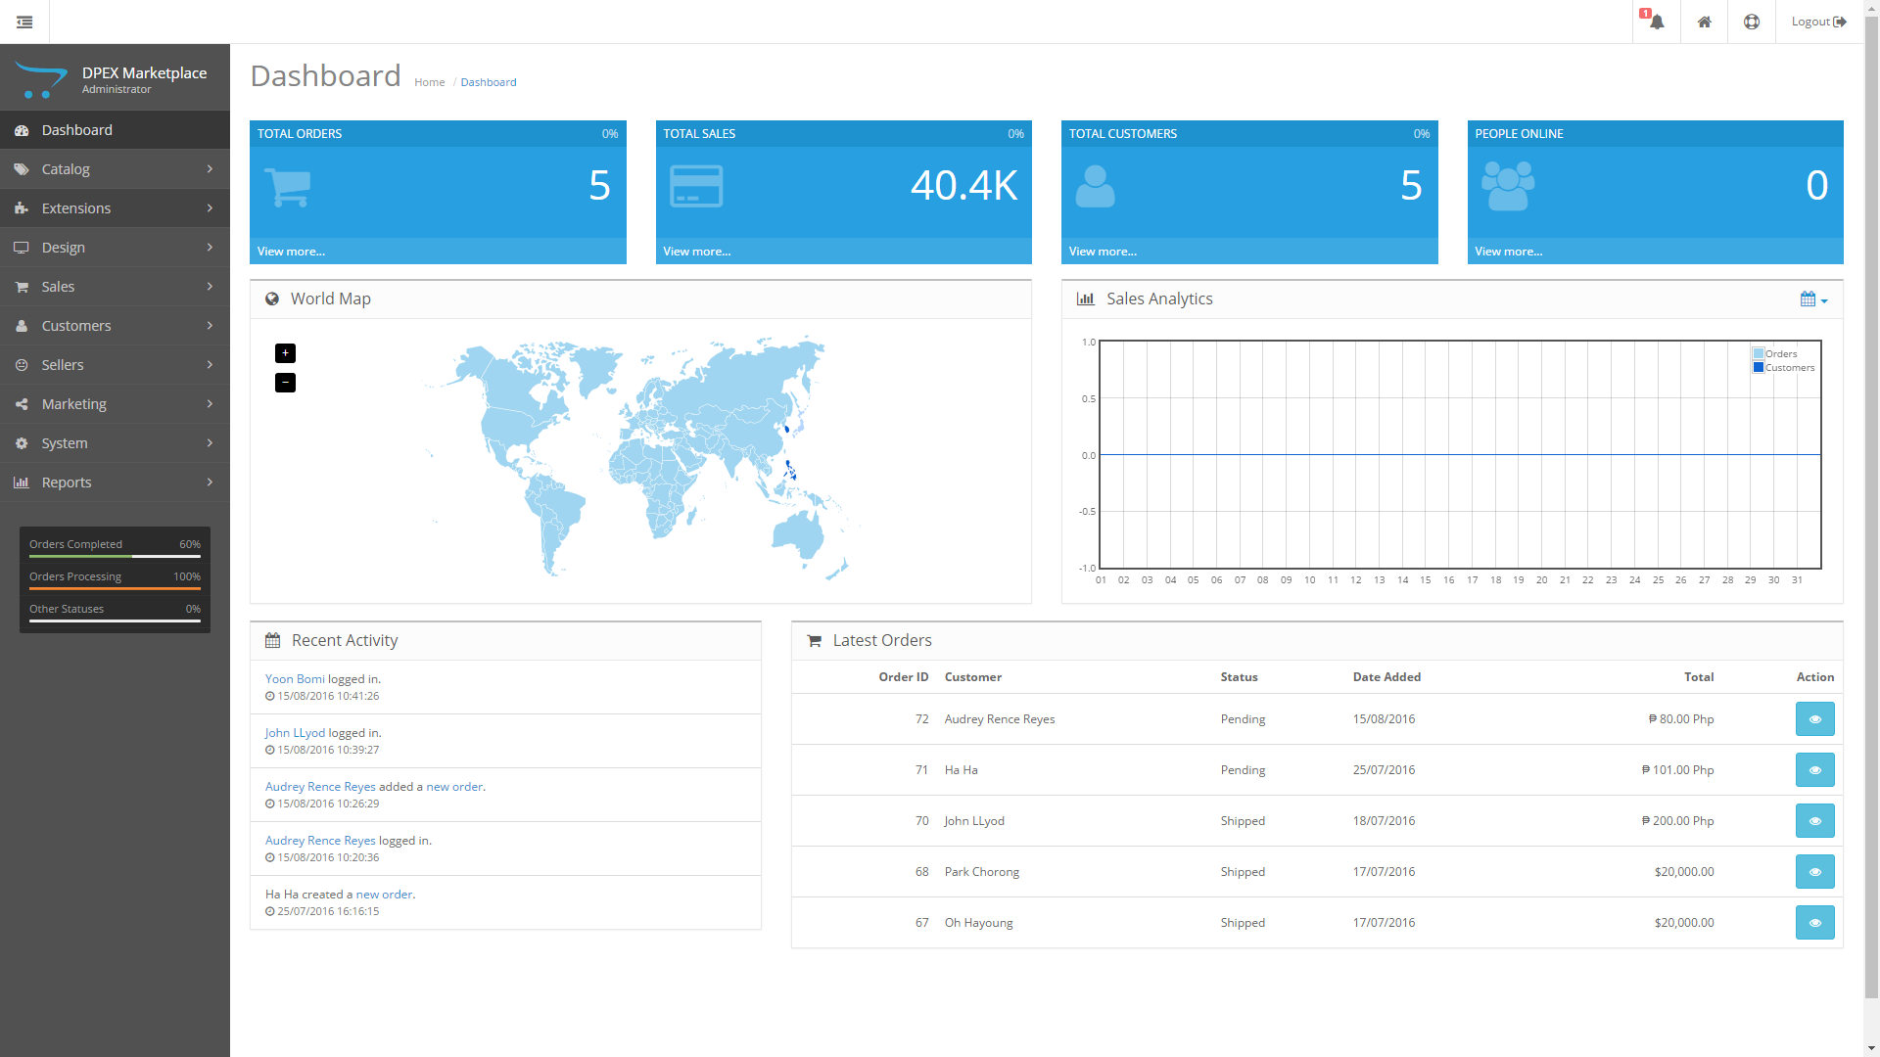

Click the Seller tab in the dashboard to view all the approved merchants

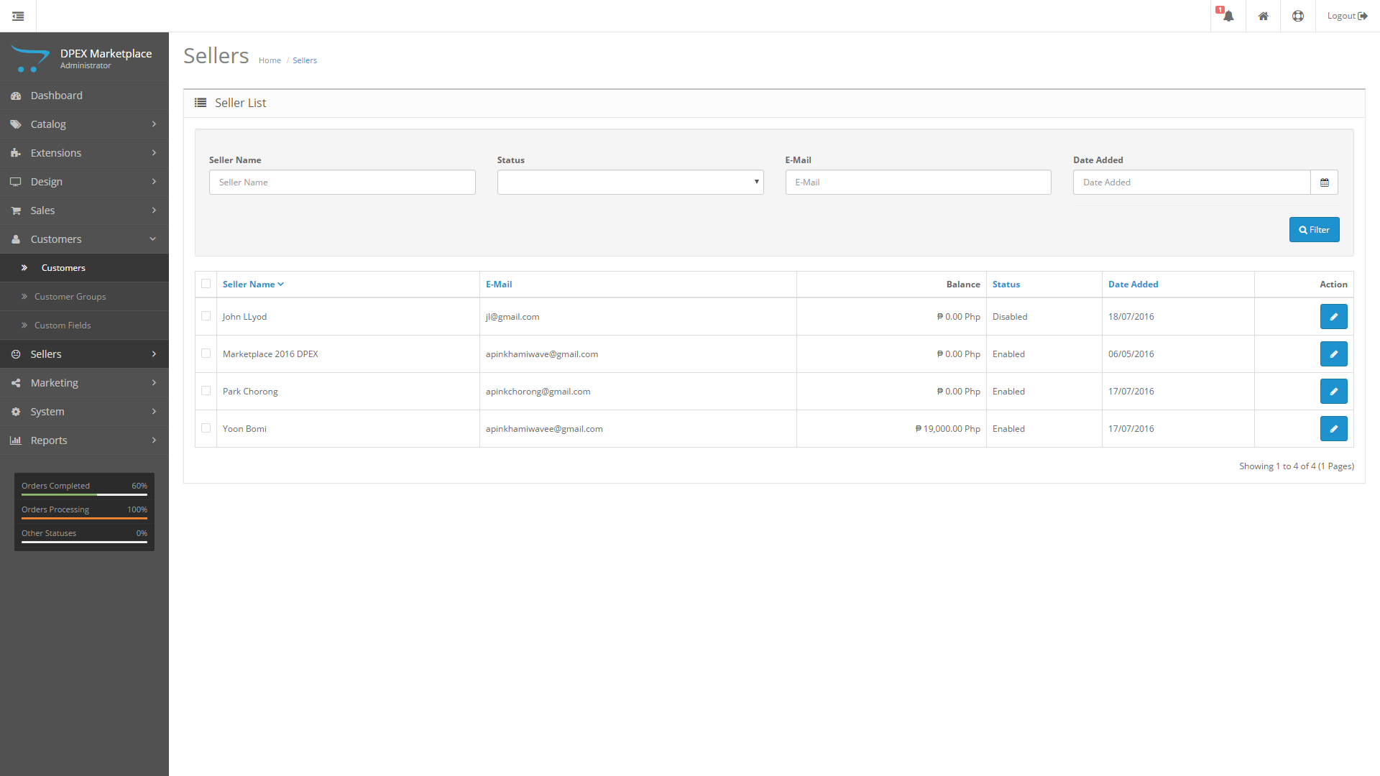

**Suspending merchants**



From the seller page click the edit button beside the seller you want to suspend located below the action column.

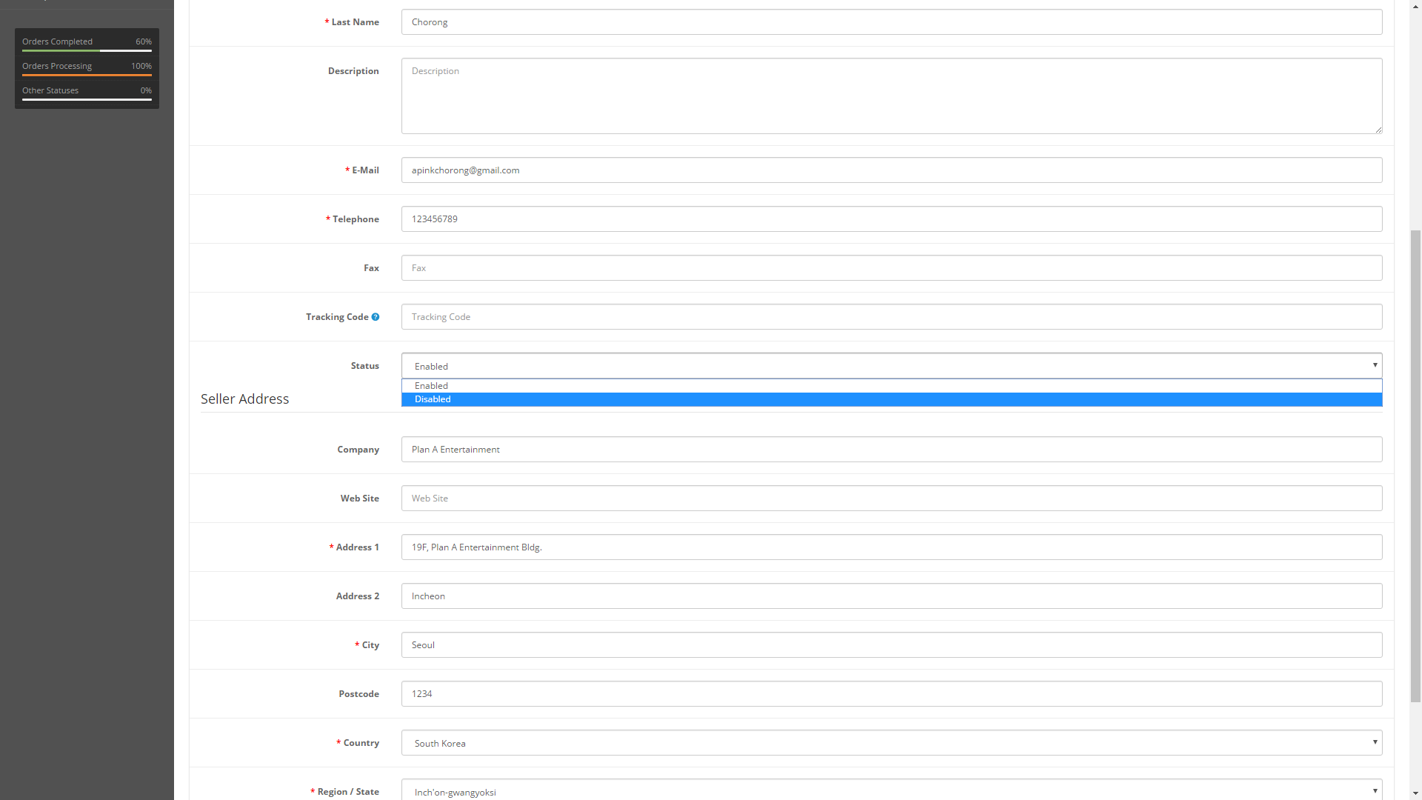

Click the Status tab below the tracking code line and change the enabled to disabled in order to suspend the seller you can also change it back to enabled to reinstate the seller.

**Viewing Transactions**

Right now you can only view the transaction per customer in order to access it from dashboard click sales then orders.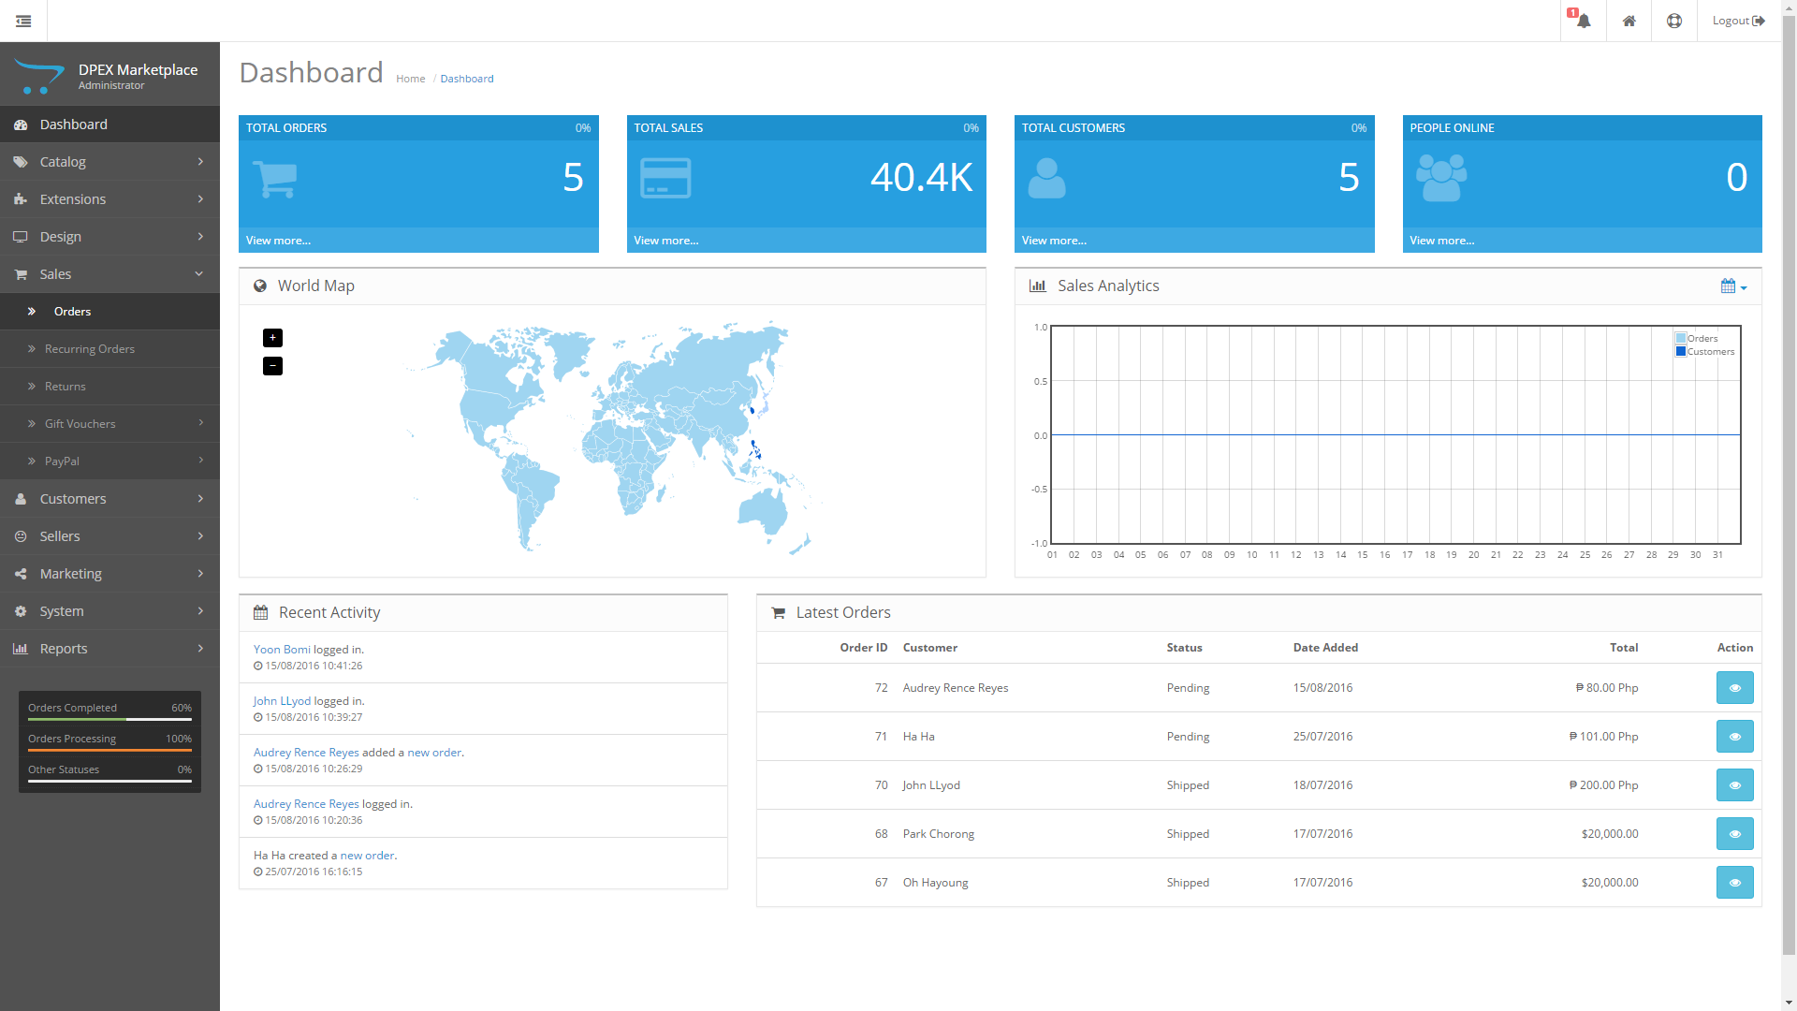

This will show you all the transactions sorted by costumer click view to see the details of the transaction